Time Intelligence (Advanced) in Power BI DAX
Time Intelligence functions help analyze data across different periods such as Year-to-Date (YTD), Month-to-Date (MTD), Quarter-to-Date (QTD), Previous Year comparisons, and date shifting.

1. YTD (Year-To-Date), MTD (Month-To-Date), QTD (Quarter-To-Date)
What is YTD?
Calculates cumulative value from the beginning of the year until the selected date.
Example
Date | Sales
Jan | 10,000
Feb | 15,000
Mar | 20,000
YTD for March = 10,000 + 15,000 + 20,000 = 45,000

DAX Formula
Sales YTD =
TOTALYTD(
SUM(Orders[Sales]),
Orders[Order Date]
)

Steps
- Create a Calendar Table.
- Mark it as Date Table.
- Create New Measure.
- Enter TOTALYTD formula.
- Use in Matrix or Line Chart.
Visual
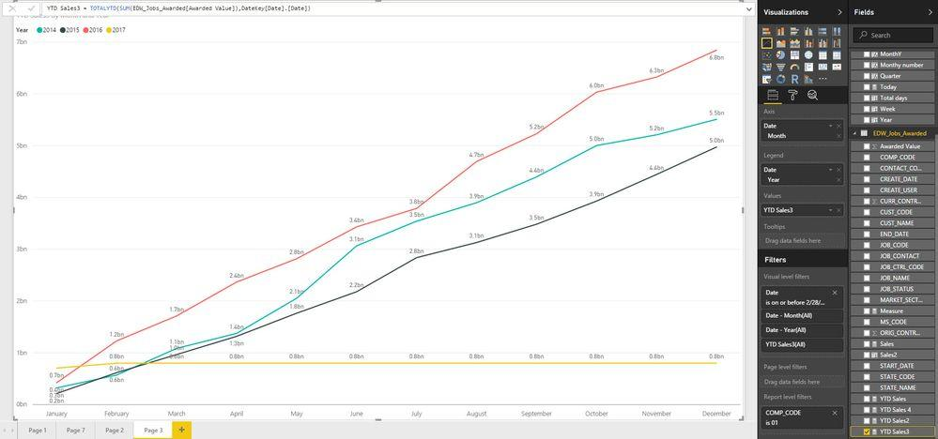
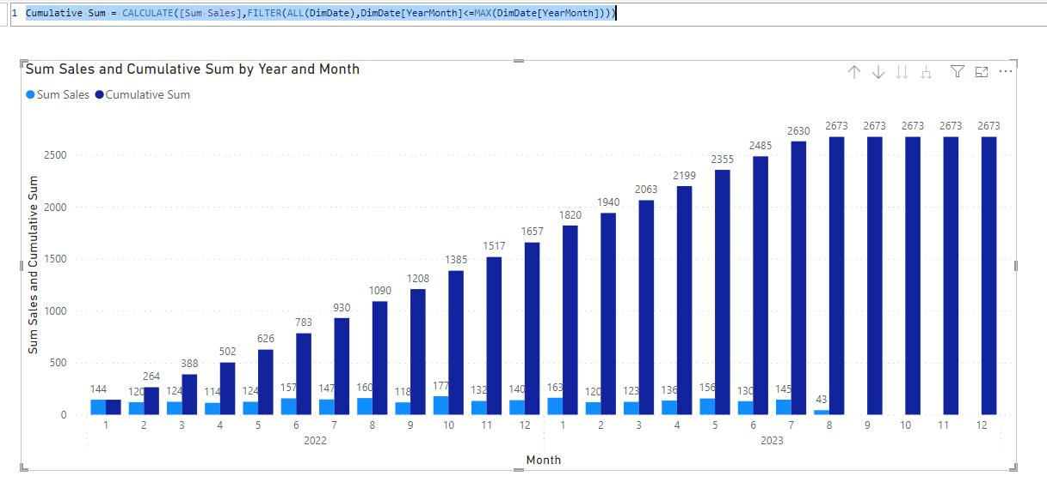
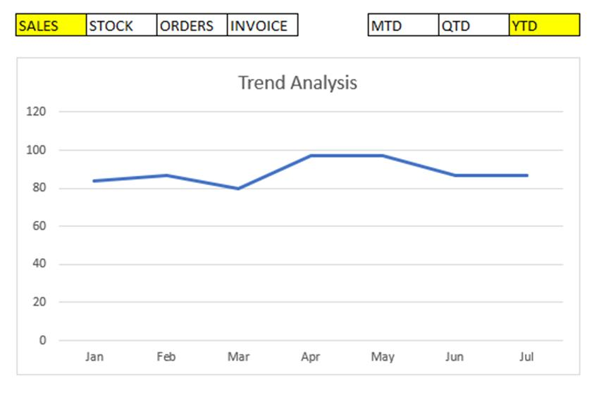

What is MTD?
Calculates cumulative value from the beginning of the month till selected date.
DAX Formula
Sales MTD =
TOTALMTD(
SUM(Sales[SalesAmount]),
Calendar[Date]
)
Steps
- Create Measure.
- Use TOTALMTD.
- Add Month slicer.
- Observe cumulative monthly sales.
Visual
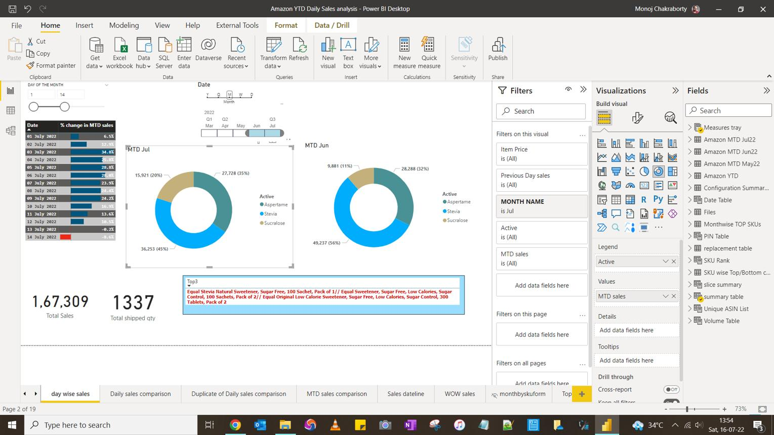
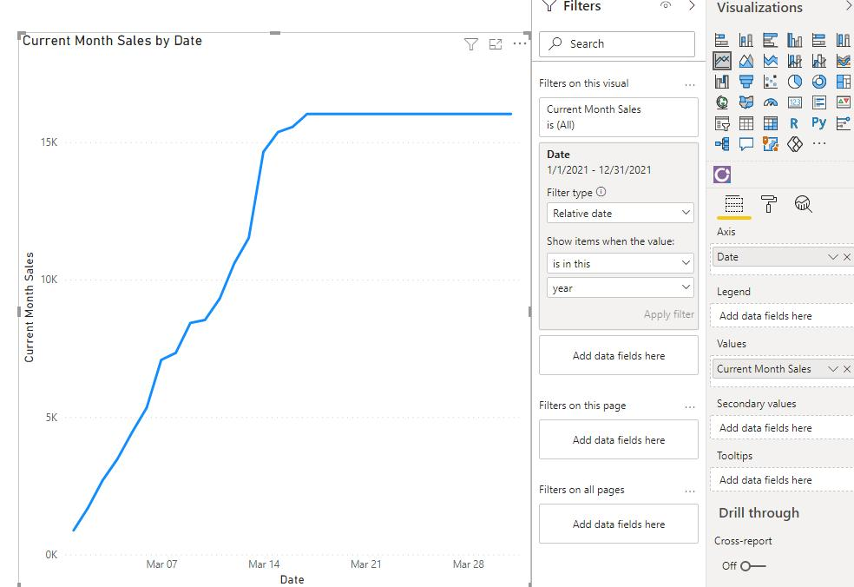
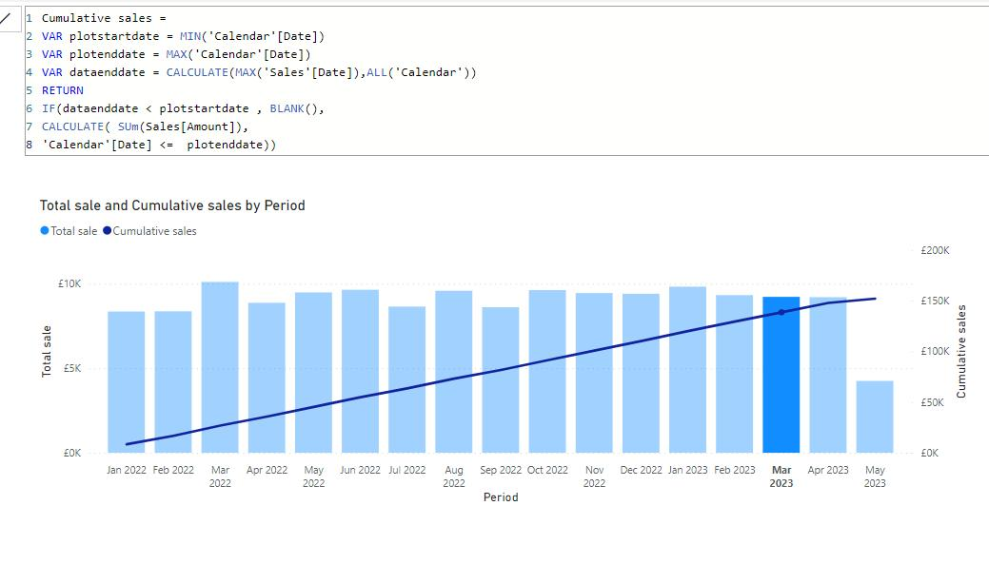

What is QTD?
Calculates cumulative value from beginning of quarter till selected date.
DAX Formula
Sales QTD =
TOTALQTD(
SUM(Sales[SalesAmount]),
Calendar[Date]
)
Steps
- Create Measure.
- Use TOTALQTD function.
- Add Quarter field.
- Display results in chart.
Visual
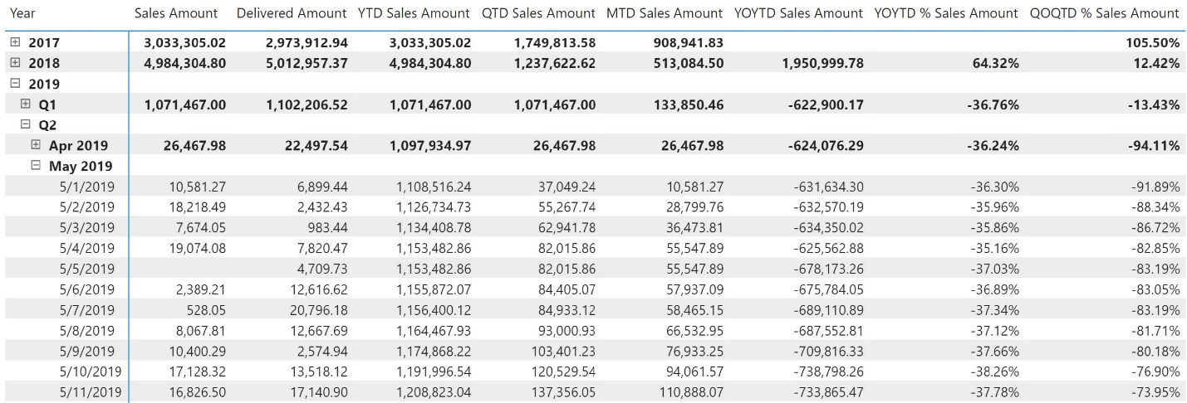
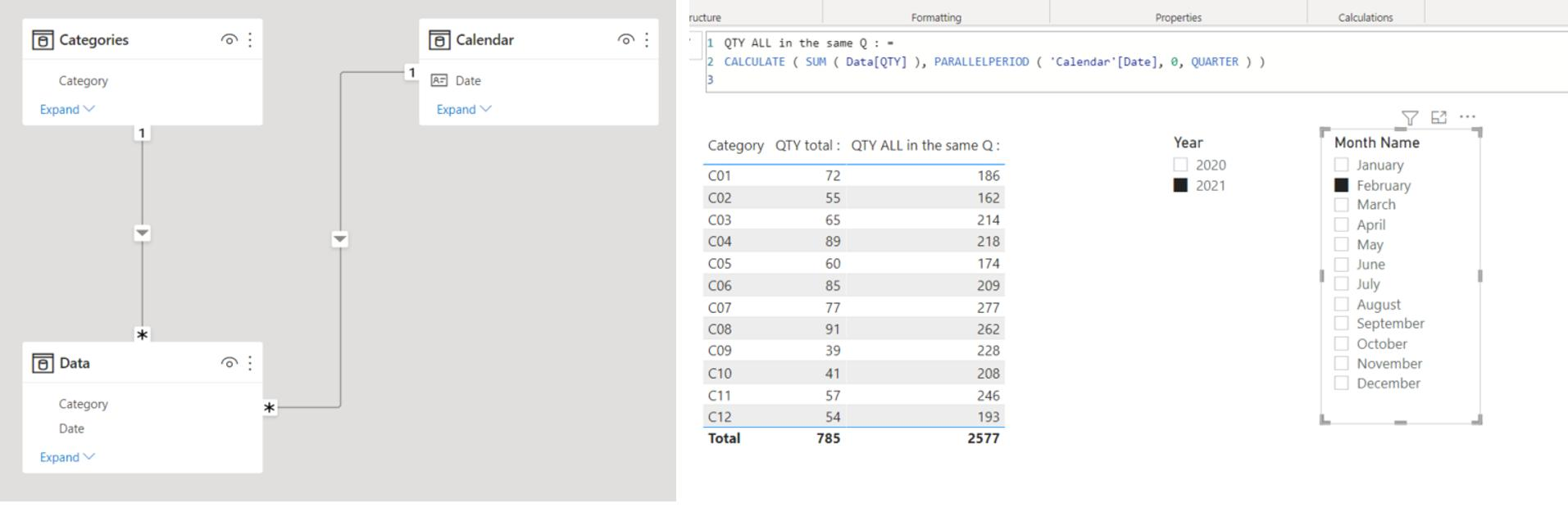
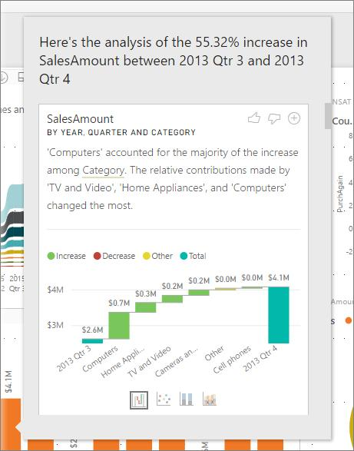

2. SAME PERIOD LASTYEAR
Purpose
Compares current period with the same period of previous year.
Example
Year | Sales
2024 | 100,000
2025 | 120,000
Previous Year Sales for 2025 = 100,000
DAX Formula
Sales LY =
CALCULATE(
SUM(Sales[SalesAmount]),
SAMEPERIODLASTYEAR(Calendar[Date])
)
Growth Calculation
Growth % =
DIVIDE(
[Current Sales] - [Sales LY],
[Sales LY]
)
Steps
- Create Sales LY measure.
- Create Growth % measure.
- Add Year and Sales into Matrix.
- Compare current year with previous year.
Visual
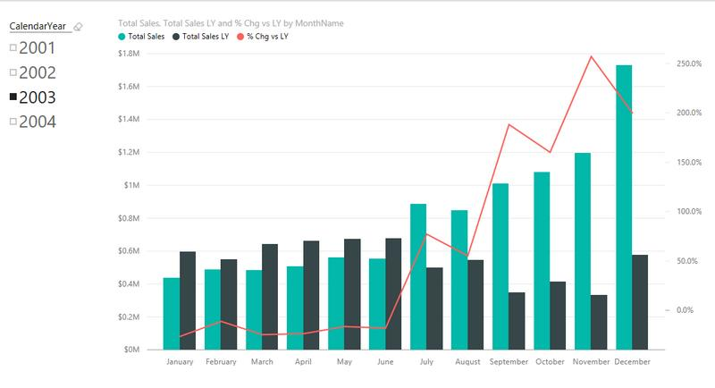
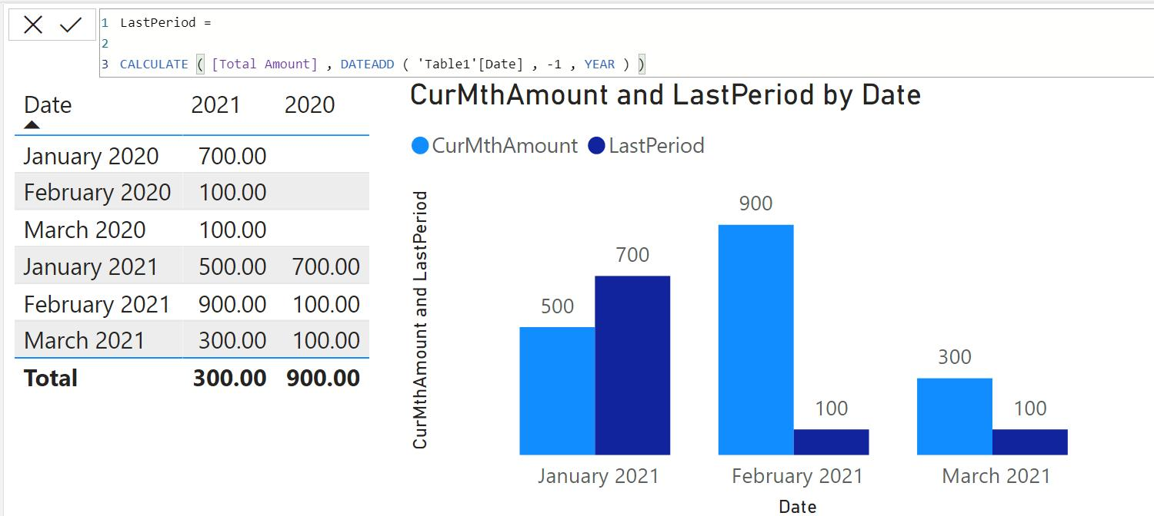
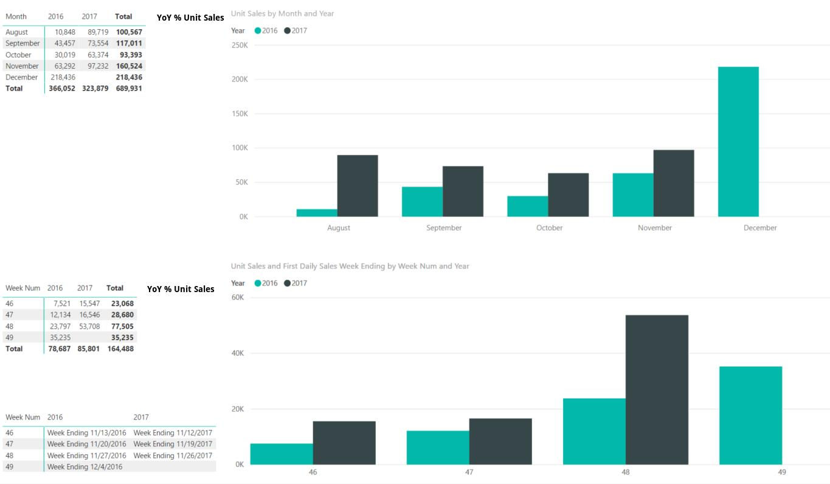

3. DATEADD Function
Purpose
Shifts dates forward or backward.
Syntax
DATEADD(
Calendar[Date],
-1,
YEAR
)
Previous Year Sales
Sales Previous Year =
CALCULATE(
SUM(Sales[SalesAmount]),
DATEADD(Calendar[Date],-1,YEAR)
)
Previous Month Sales
Sales Previous Month =
CALCULATE(
SUM(Orders[SalesAmount]),
DATEADD(Calendar[Date],-1,MONTH)
)
Steps
- Create Measure.
- Use DATEADD.
- Specify interval:
  - DAY
  - MONTH
  - QUARTER
  - YEAR
- Add chart for comparison.
Visual
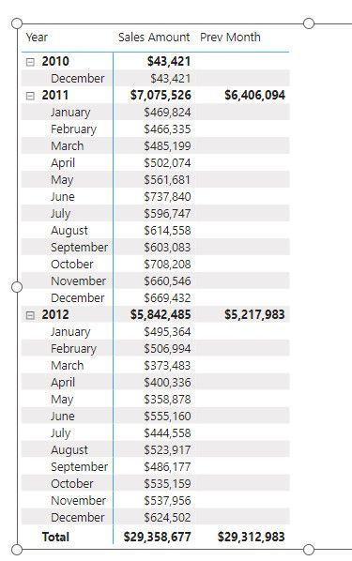
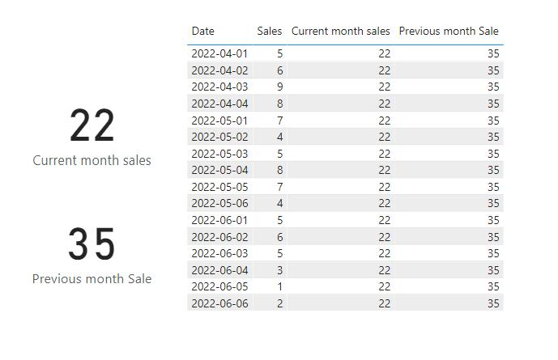
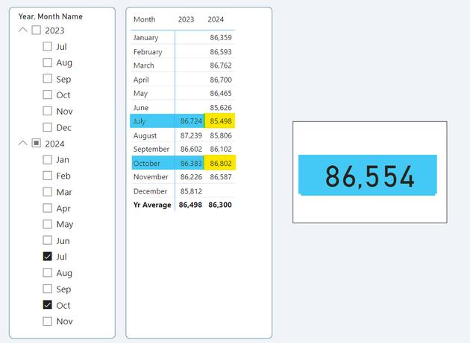

4. PARALLELPERIOD Function
Purpose
Returns a complete previous or future period.
Difference
DATEADD | PARALLELPERIOD
Shifts individual dates | Shifts entire period
Flexible | Period based
Previous Year Sales
Sales Previous Year =
CALCULATE(
SUM(Sales[SalesAmount]),
PARALLELPERIOD(
Calendar[Date],
-1,
YEAR
)
)
Previous Quarter Sales
Sales Previous Quarter =
CALCULATE(
SUM(Sales[SalesAmount]),
PARALLELPERIOD(
Calendar[Date],
-1,
QUARTER
)
)
Steps
- Create Measure.
- Use PARALLELPERIOD.
- Select interval.
- Compare periods in visuals.
Visual
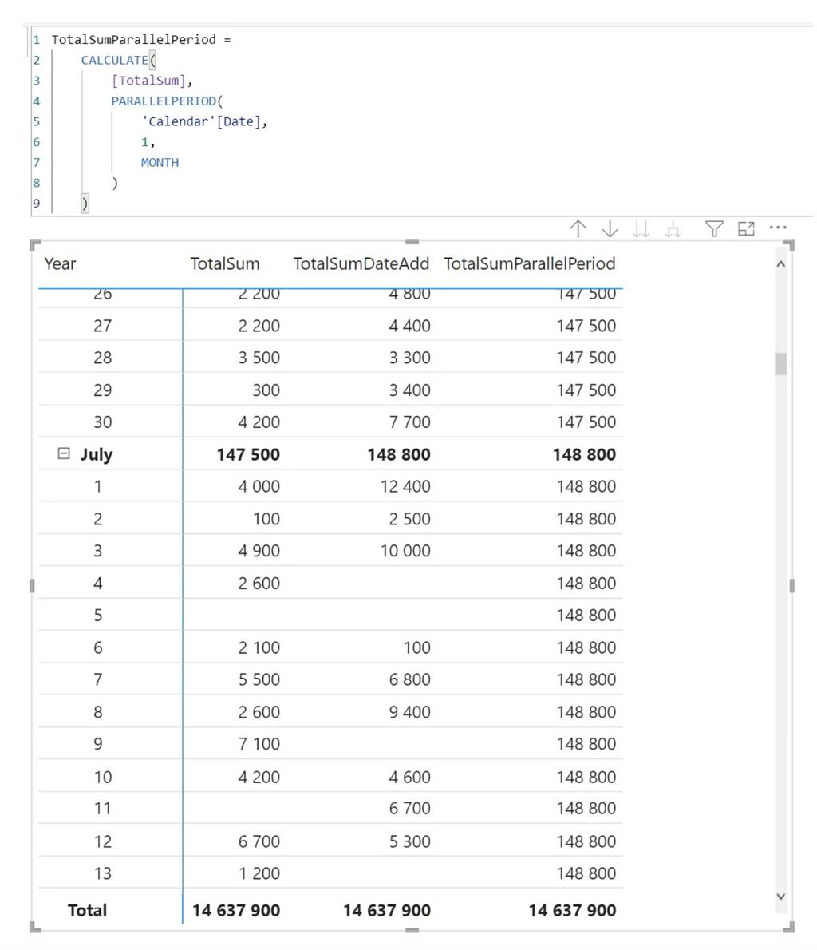
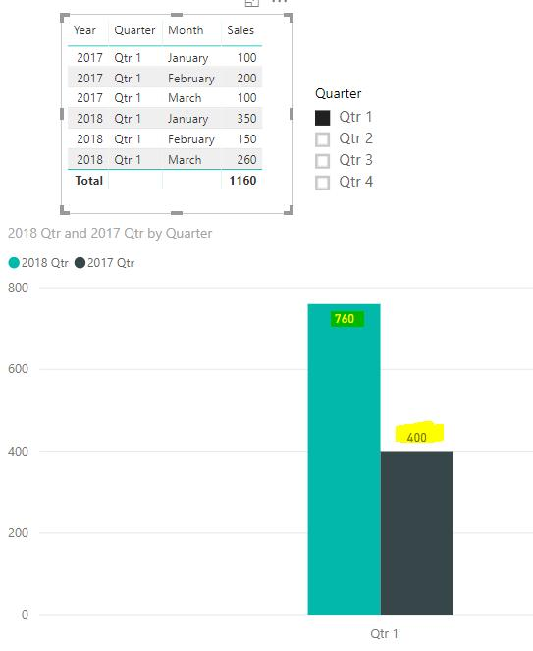
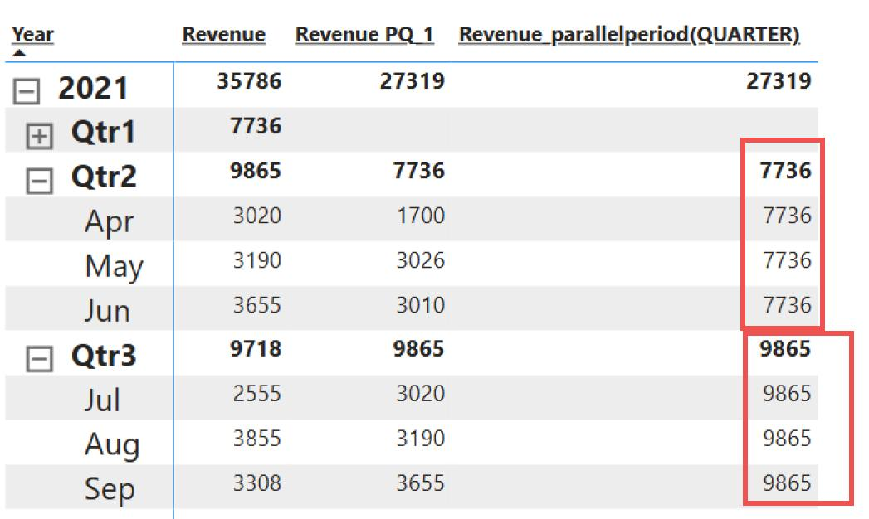

5. Custom Calendar Table Creation
A Calendar Table is mandatory for advanced Time Intelligence.
DAX Calendar Table
Calendar =
ADDCOLUMNS(
CALENDAR(
DATE(2020,1,1),
DATE(2030,12,31)
),
"Year", YEAR([Date]),
"Month Number", MONTH([Date]),
"Month", FORMAT([Date],"MMMM"),
"Quarter", "Q" & FORMAT([Date],"Q")
)
Steps
Step 1
Go to:
Modeling → New Table
Step 2
Paste Calendar DAX.
Step 3
Create Relationship
Calendar[Date]
↓
Sales[Order Date]
Step 4
Mark as Date Table
Table Tools
↓
Mark as Date Table
↓
Select Date Column
Step 5
Use Calendar fields in all reports.
Calendar Structure
Calendar Table
│
├── Date
├── Year
├── Quarter
├── Month Number
├── Month Name
└── Week
Visual
